Bryant University   
Health Checker User Guide

1. All Bryant University individuals are asked to perform a daily health attestation. Bryant University has tried to make this easy and convenient for all Bryant University Faculty, Staff, and Students.
2. The Health Checker applet is available within the Bryant Mobile App.
   1. The Bryant Mobile App can be downloaded from the Google Play Store or Apple App Store – search for “Bryant Mobile App”
3. Everyone should be doing this daily health attestation at home before they leave for work or in their resident hall rooms before they leave their resident hall for the first time for the day.
4. Open the Bryant Mobile App to get to the main screen.

|  |  |
| --- | --- |
| This is what you see when **NOT** logged into the mobile app Image  Login button Not logged in | This is what you see when you **ARE** logged into the mobile app Image  Login button  Now logged in |

1. The Health Checker applet is located first in the list of applets.
   1. If you log into the mobile app first, then you will not need to enter in your name and email address in the Health Checker screen.
      1. To login click the small icon located in the upper right of the screen.
      2. Enter your normal Bryant credentials
      3. You will see more applets on the screen when you are logged in
      4. The app will keep you logged in even after you close the app so you only need to do it once
2. Click on the Health Checker applet and you will see the following:

|  |  |
| --- | --- |
| This is the top section of the Health Checker screen. If you logged in, the **First Name**, **Last Name** and **Email** will be populated for you. Otherwise you will need to type this information in yourself, it is required.  You may also enter in your phone number, in case you need to be reached, but it is optional. | This is how the buttons change if you click on any of the symptoms/risk factors. All buttons should remain white (not selected) unless you are truly reporting you are not feeling well.    This is the bottom portion of the screen. You are **required** to check the box to **CONFIRM** that you have NO symptoms or risk factors. (If you select a symptom or risk factor, you do not check the box)  **Enter your initials** to certify you are reporting accurate information at the time of submission.  Click the **Send Health Form** button. |

1. After submitting the form, if you did not click any of the symptoms/risk factors, you will receive a green check Health Pass.
   1. To bring up your pass quickly, you can either take a screenshot on your phone, open the app and click on the Health Checker applet and it will bring up the pass, or you will also receive an email that contains a link to this pass  
      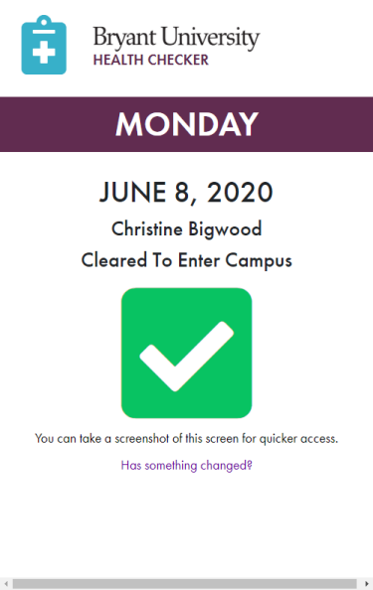
2. You will **stop** **and show this pass** at the Entry Control Station when you drive onto campus. If you also go to other locations on campus, you may be asked to show this pass as well.
3. You will need to do this every day, the pass expires at 3:00 AM the following day.
4. If you start the day feeling fine, but start to exhibit symptoms, you can click the “Has something changed?” link on the pass to bring up your good pass and then you can select the symptoms you are experiencing and submit the form. Employees are then to inform their supervisor and HR that they are leaving campus. Students are to contact Health Services.
5. If you click any symptoms/risk factors, you will be placed in Quarantine/Isolation.

|  |  |
| --- | --- |
| This is the screen you will receive as an **Employee**: | This is the screen you will receive as a **Student**: |

1. If you happen to submit the form by accident with a symptom/risk factor selected, but you DO NOT have any of these reported symptoms/risk factors, employees contact Human Resources (students contact Health Services) to confirm this mistake with them and they can then delete your entry so you can go back in and get a Good pass with the Green Check.
2. Employees in quarantine will be contacted by Human Resources within 24hrs and then will coordinate with Human Resources what the next steps will be. Students will need to coordinate with Health Services as to their next steps.